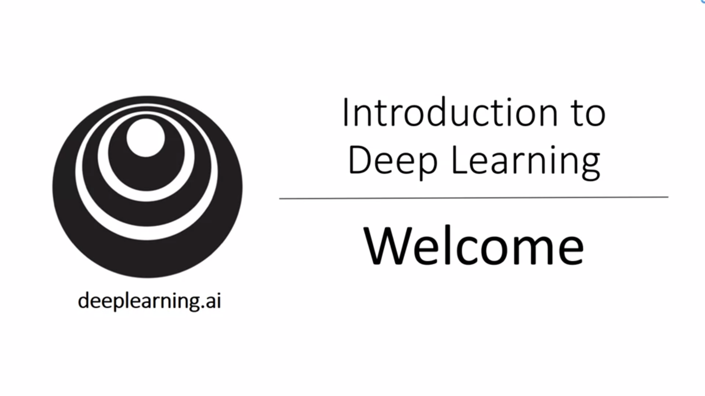

Deep learning has already transformed traditional online businesses such as web search and advertising but it is also enabling completely new products and businesses (for example better healthcare – reading x-ray images, personalized education, precision agriculture, self-driving cars etc.). In the coming decades we can build an amazing world that is AI powered.

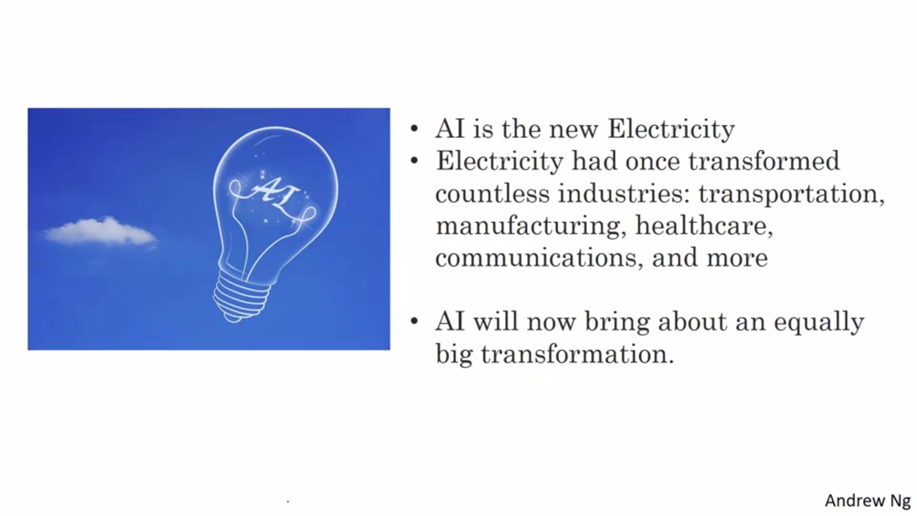

100 years ago electrification changed every major industry. AI can bring an equally big transformation. Deep learning is one of the most highly sought after skills in the technology world.

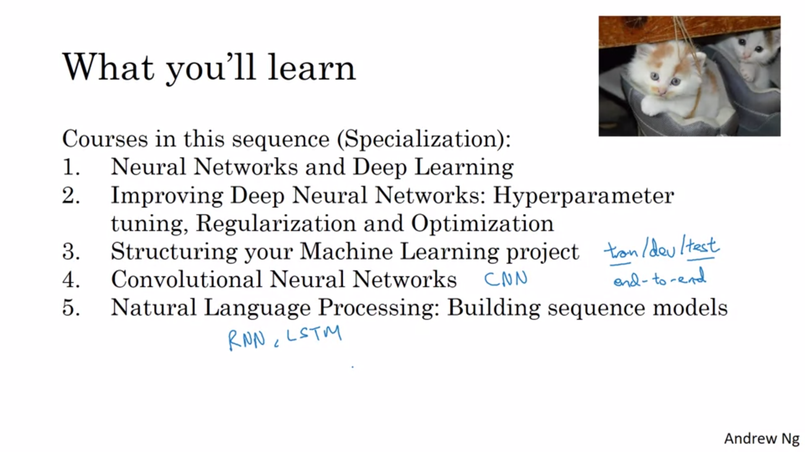

The first course covers fundamentals. The second course will demistify the “black magic” around tuning. We will learn how to make neural networks work well. The third course will cover strategies to build machine learning systems. These strategies have changed in the era of deep learning (e.g. split of train/dev/test set. We also learn more about end-to-end deep learning. Andrew will share what he has learned while shipping a huge amount of deep learning products. The fourth course will be about CNNs, which are often applied to images. In course 5 we learn about sequence models and natural language processing. Sequence models include RNN, LSTM, GRU for example. These models can be used for example for machine translation and music generation.

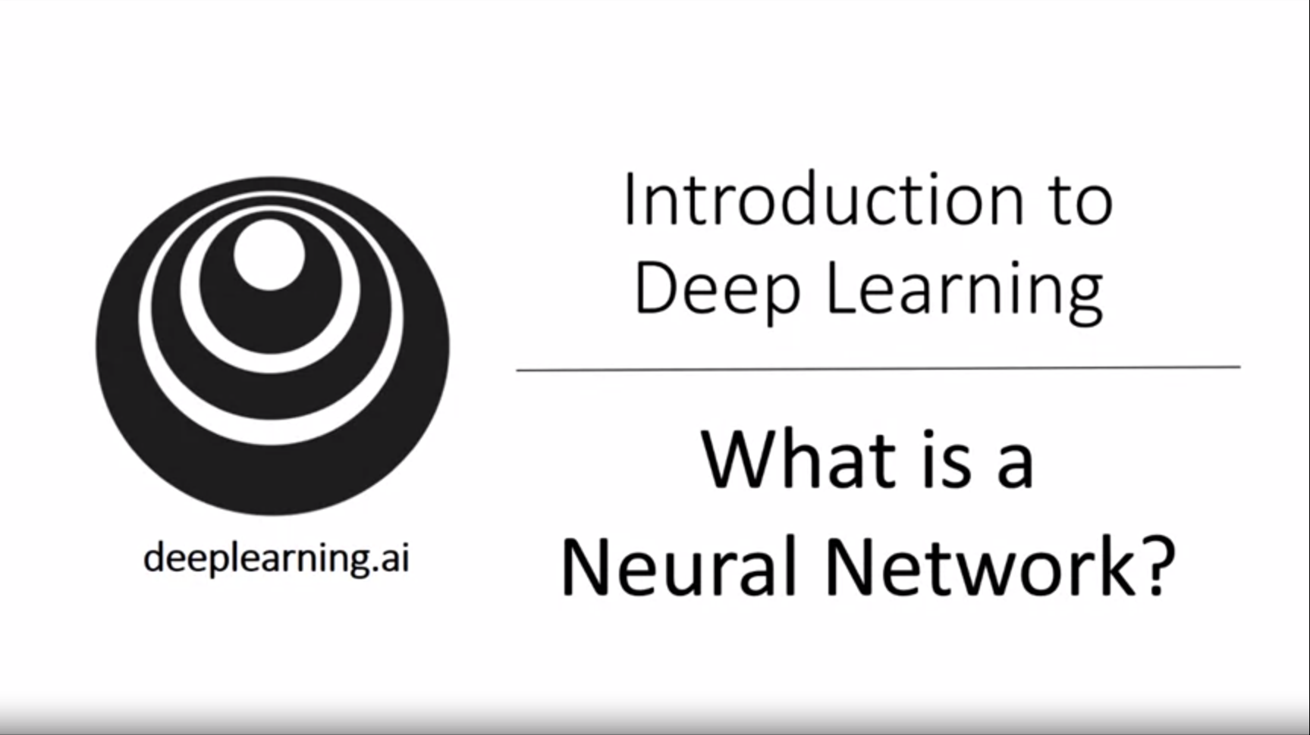

Deep learning = training very large neural networks.

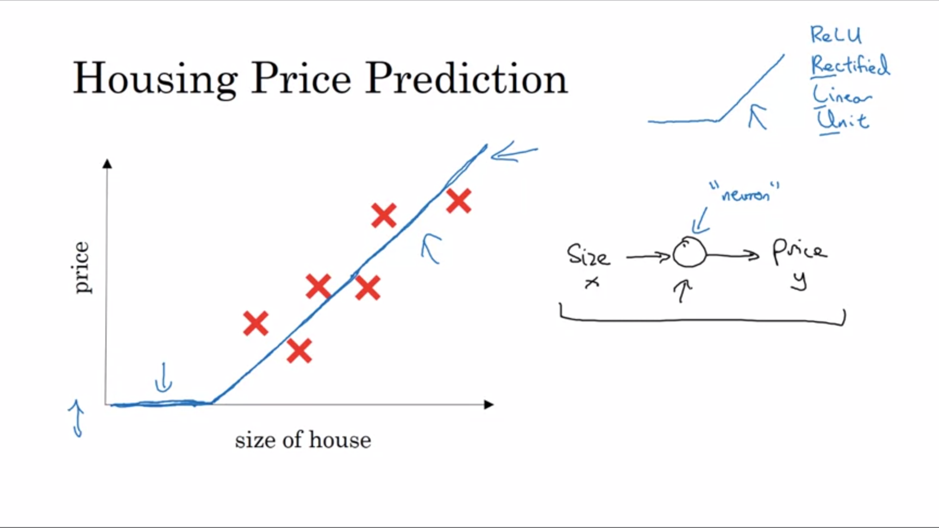

House prices do not get negative so set the function to 0 instead. This function is a very simple neiural network. A larger neural network is formed by taking many of these single neurons and stacking them together.

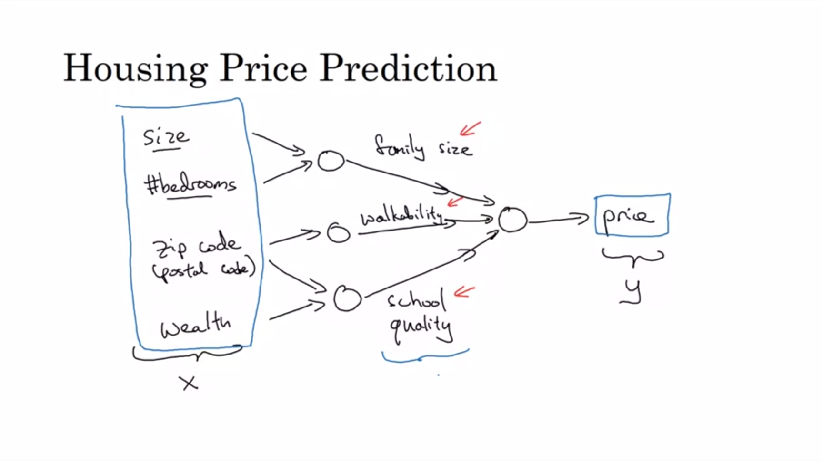

Now we have multiple features. Each of the circles is a slightly non-linear function, e.g. Relu. The features build some “intermittent features” that the people care about to determine the price. The magic of a neural network is that it will figure out the intermittent features given x and y.

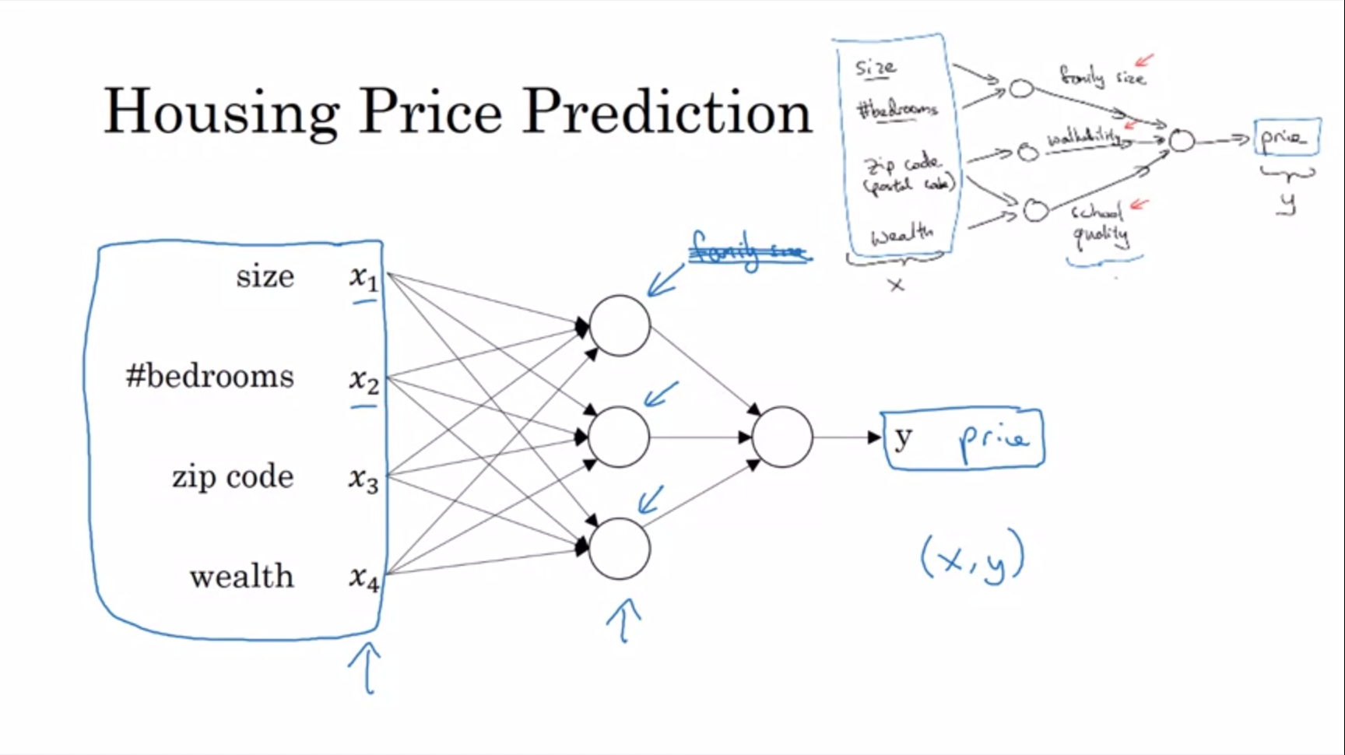

This is what you actually implement. Given x the job of the neural network will be to output y. Here all neurons are connected to all input features and the neural network will figure out the weights. This is called a densely connected neural network. Given enough training examples, neural networks are remarkably good at figuring out functions to map from x to y. Neural networks are most powerful in supervised learning settings (at least as of now).

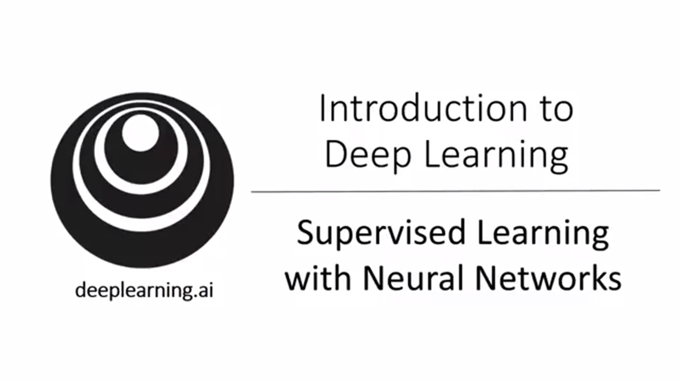

Some more examples of supervised learning. Almost all the economic value created through neural networks was related to supervised learning. The most lucrative application today is online advertising.

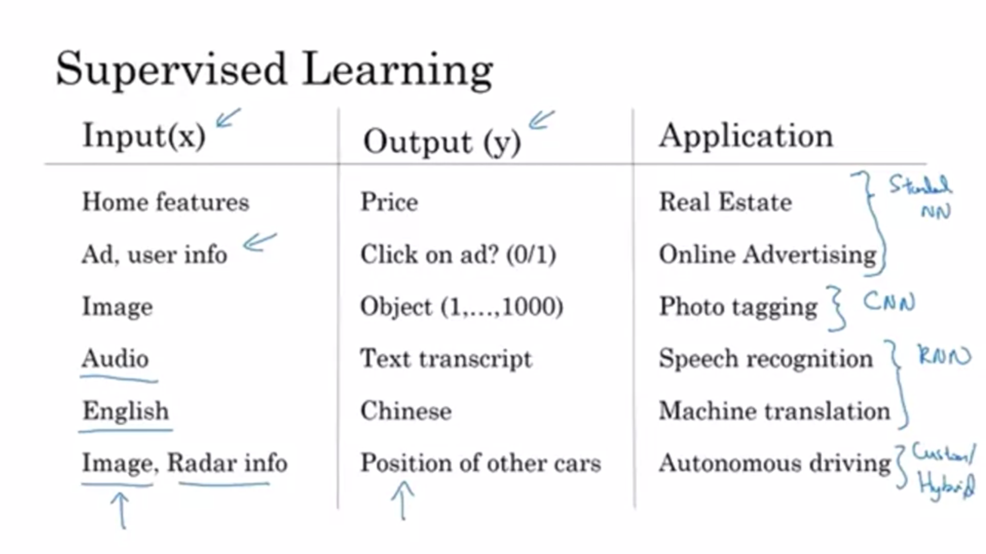

Often times supervised learning applications are integrated into bigger systems (e.g. for autonomous driving). CNNs are often used for image data. RNNs are used for sequence data (lots of times with temporal component).

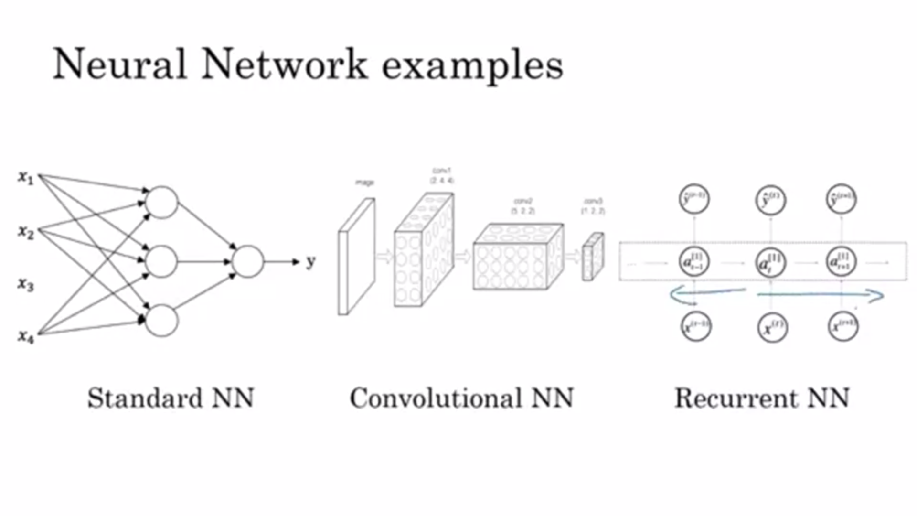

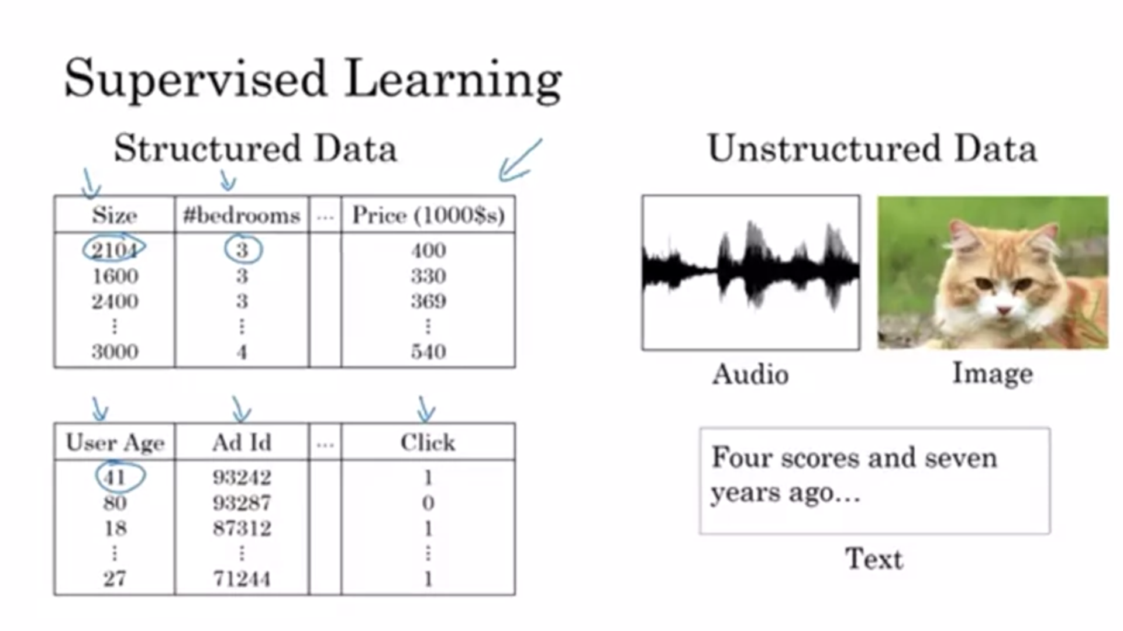

Structured data: databases of data (with columns); each of the features has a very well-defined meaning

Unstructured data: raw audio, images, text; here the features are e.g. pixel values or individual words in a text. Historically it has been much harder for computers to make sense of unstructured data. Humans are very good at this. One of the exciting things of deep learning is that computers are now much better at interpreting unstructured data, too. This gives rise to lots of new applications that were not possible previously. In the media you hear more about successes of deep learning with unstructured data (because it seems more interesting). A lot of the short term economic value, however, has been on structured data.

The concepts learned in this class mostly apply for structured and unstructured data.

The basic technical ideas of neural networks have been around for decades. Why is it that only recently it has taken off? Know why this is the case will also help to spot opportunities within organizations.

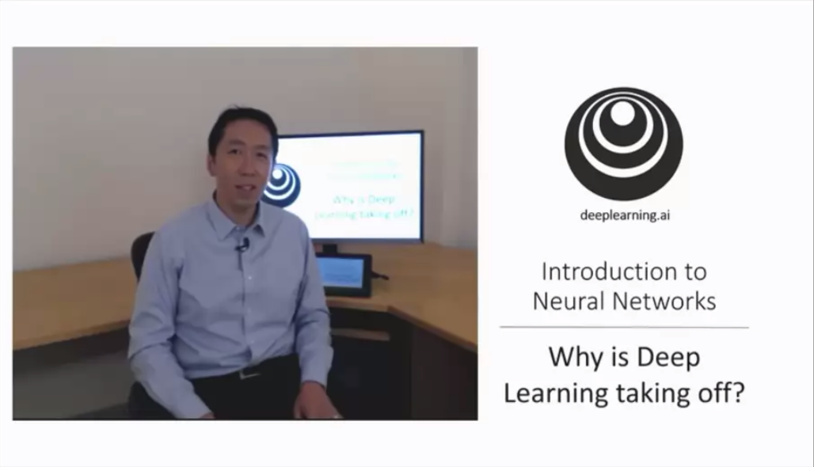

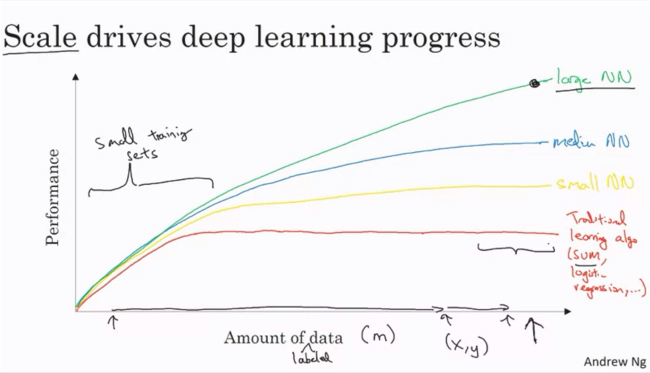

When Andrew is asked this question, he will draw this plot. Performance could for example be accuracy of an ad classifier. It is like traditional algos do not know what to do with huge amounts of data. Through the digitization of human society with so much activity now generating data we have moved to the right side of the x axis. Also lots of new sensors (expensive cameras in smartphones, accelerometers in IoT etc.) -> We have been collecting more and more data (more than traditional algos can effectively take advantage of). For very high performance you need two things: be able to train a big enough neural network and a lot of data. Scale refers to both! Two of the most reliable ways to improve neural network performance are to throw more data at it or train a larger NN. That only works up to a point in practice. In the small training sets area the relative ordering of the algorithms is actually not very well defined. It could be that traditional algos work better. It is often more important that the engineer has good skills in handengineering features.

In the early days of the rise it was scale of data and scale of computation. Increasingly there also has been tremendous algorithmic innovation. Lots of these innovations aim at making computation faster (e.g. switching from a sigmoid activation function to a Relu activation function. Open source was also a major contributor to the rise. Problem with sigmoid is that with gradient descent the gradients become very low if not close to 0 so the algorithm is slow. With Relu the gradient is much more less likely to shrink to 0. There are lots of similar examples like this.

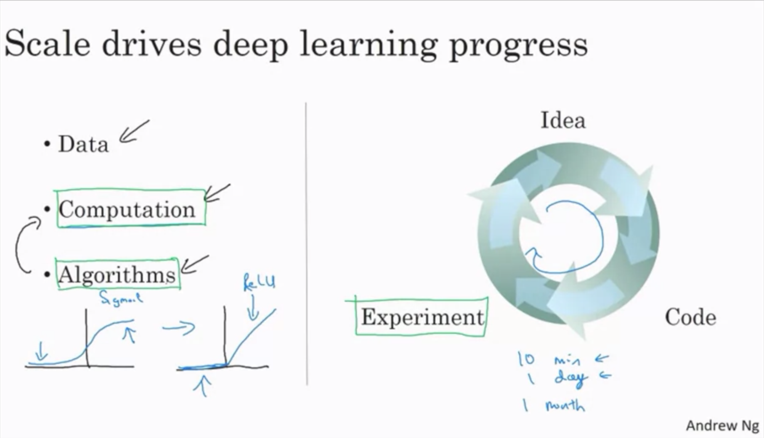

The process of training neural networks is very iterative. Often you want to experiment with new ideas and then look at the outcomes to change the details and go into the next round of the circle. If the NN takes long to train, it takes a long time to get around this circle. So there is a huge difference in productivity for the developer with fast computation. The developer can try more ideas and is much more likely to find a NN that works well for their application.

This trend of data and computation with GPUs and faster networks will continue. We can be optimistic that deep learning will become better for many years to come.

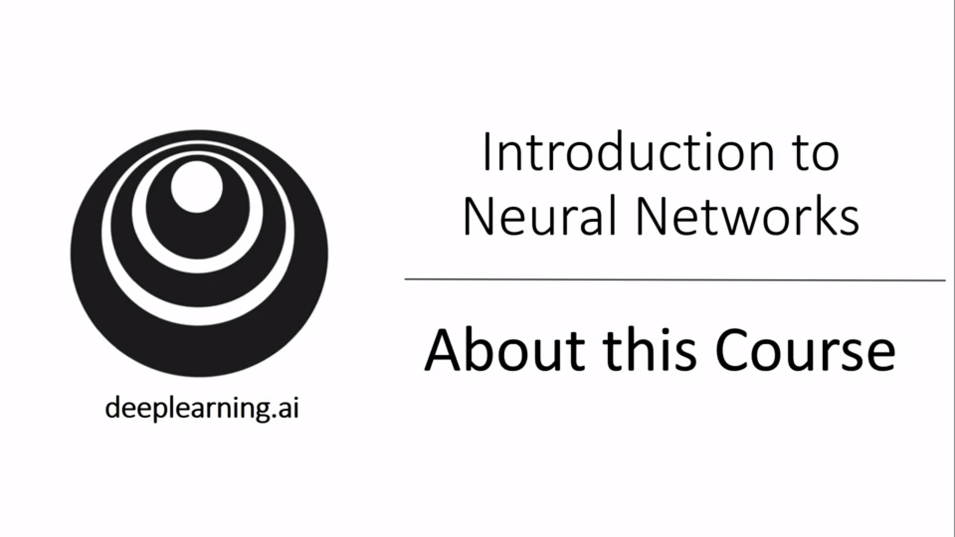

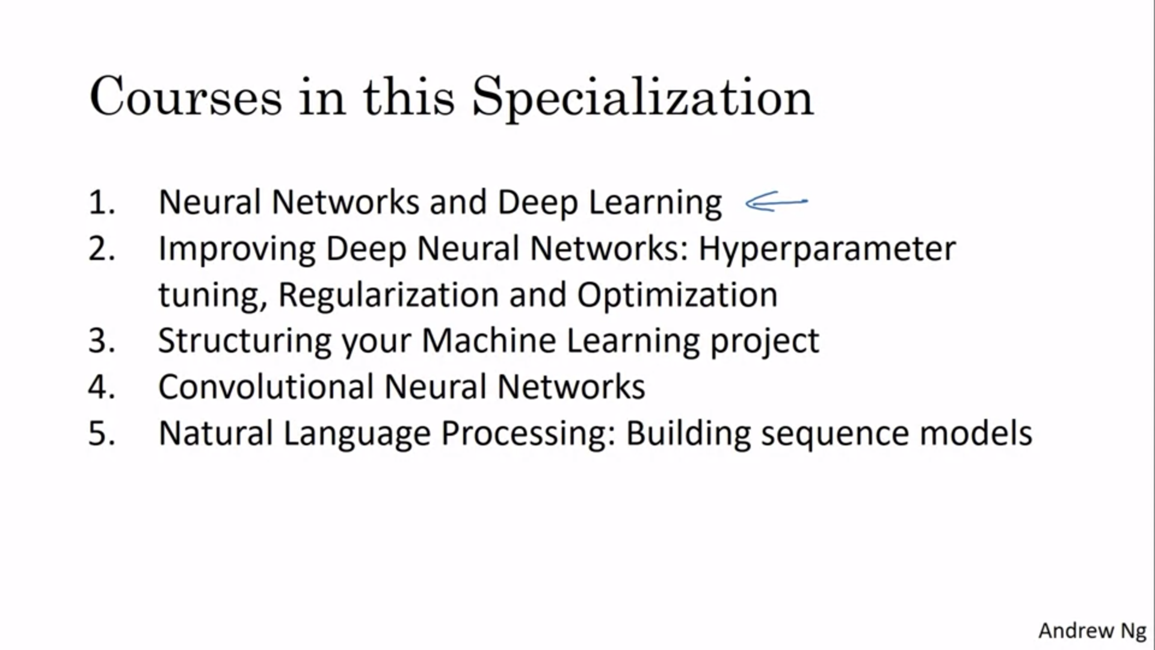

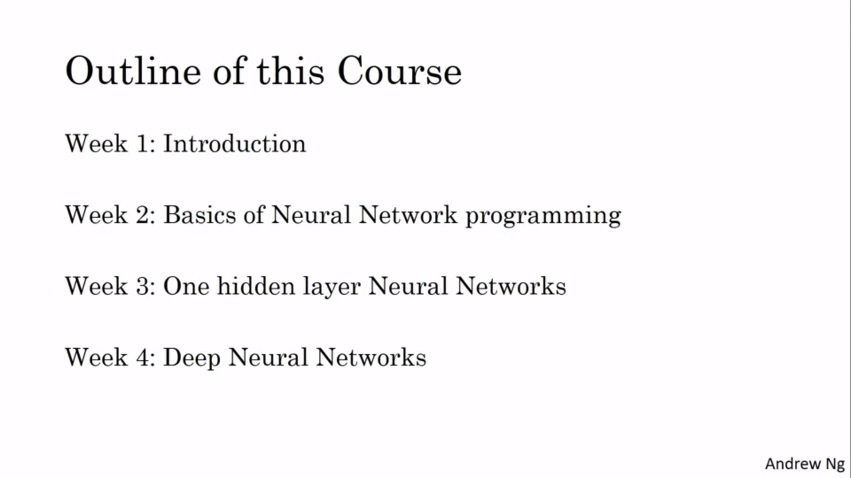

Basics of neural network programming: forward propagation, backward propagation, implement algorithms.­­